
Client Name: | Bank Danamon - NGI
Module Name: | Specification document CR_20240012 Customer Memo Maintenance  Version 1.0
RS TAG:
RS Name
API Specifications

Oracle Financial Services Software Limited
Oracle Park
Off Western Express Highway
Goregaon (East)
Mumbai, Maharashtra 400 063
India
Worldwide Inquiries:
Phone: +91 22 6718 3000
Fax:+91 22 6718 3001
www.oracle.com/financialservices/

Copyright © 2023, Oracle and/or its affiliates. All rights reserved.

Oracle and Java are registered trademarks of Oracle and/or its affiliates. Other names may be trademarks of their respective owners.
U.S. GOVERNMENT END USERS: Oracle programs, including any operating system, integrated software, any programs installed on the hardware, and/or documentation, delivered to U.S. Government end users are “commercial computer software” pursuant to the applicable Federal Acquisition Regulation and agency-specific supplemental regulations. As such, use, duplication, disclosure, modification, and adaptation of the programs, including any operating system, integrated software, any programs installed on the hardware, and/or documentation, shall be subject to license terms and license restrictions applicable to the programs. No other rights are granted to the U.S. Government.

This software or hardware is developed for general use in a variety of information management applications. It is not developed or intended for use in any inherently dangerous applications, including applications that may create a risk of personal injury. If you use this software or hardware in dangerous applications, then you shall be responsible to take all appropriate failsafe, backup, redundancy, and other measures to ensure its safe use. Oracle Corporation and its affiliates disclaim any liability for any damages caused by use of this software or hardware in dangerous applications.

This software and related documentation are provided under a license agreement containing restrictions on use and disclosure and are protected by intellectual property laws. Except as expressly permitted in your license agreement or allowed by law, you may not use, copy, reproduce, translate, broadcast, modify, license, transmit, distribute, exhibit, perform, publish or display any part, in any form, or by any means. Reverse engineering, disassembly, or recompilation of this software, unless required by law for interoperability, is prohibited.
The information contained herein is subject to change without notice and is not warranted to be error-free. If you find any errors, please report them to us in writing.

This software or hardware and documentation may provide access to or information on content, products and services from third parties. Oracle Corporation and its affiliates are not responsible for and expressly disclaim all warranties of any kind with respect to third-party content, products, and services. Oracle Corporation and its affiliates will not be responsible for any loss, costs, or damages incurred due to your access to or use of third-party content, products, or services.

Document Version Control

File Name: | Specifications document CR_20240012 Customer Memo Maintenance | Creation Date: | 19-JUL-2024
Group | Consulting | Last Saved On: | 19- JUL-2024
Last saved by | Vikas Goswami | Author | Partha

Revision History

Date | Revision No | Reviewer  Name | Modified by | Description of Change
19-JUL-2024 |  |  |  | Initial version

Contents
functional specifications 2
1. Requirement Description 2
2. Current FLEXCUBE Support 2
3. General sPECfications 2
4. DetaIL SpecIFciation 2
4.1 Header 2
4.2 Body 3
4.2.1 Request 4
4.2.2 Request sample 5
4.2.3 Response 5
4.2.4 Response SAMPLE 6
5. Response codes 6
6. Additional Information 6
7. APPENDIX 6
8. END POINT URL 7

functional specifications

Requirement Description
BDI Bank uses OFCR (Oracle FLEXCUBE) as its core banking software.
A NGI service will be required to add and update customer Memo. This new NGI service will be based on existing FLEXCUBE screen – CIM13 (Customer Memo Maintenance).

Current FLEXCUBE Support
Currently (Oracle FLEXCUBE) supports branch screens to do these transactions manually.
- FP CIM13 (Customer Memo Maintenance) – Used to maintain the customer memos.
- There are Add/Delete/Modify/Inquiry options are available on this maintenance for any customer Id. But Our focus will be limited to add and update only.(Addition and Modification of Customer memo)

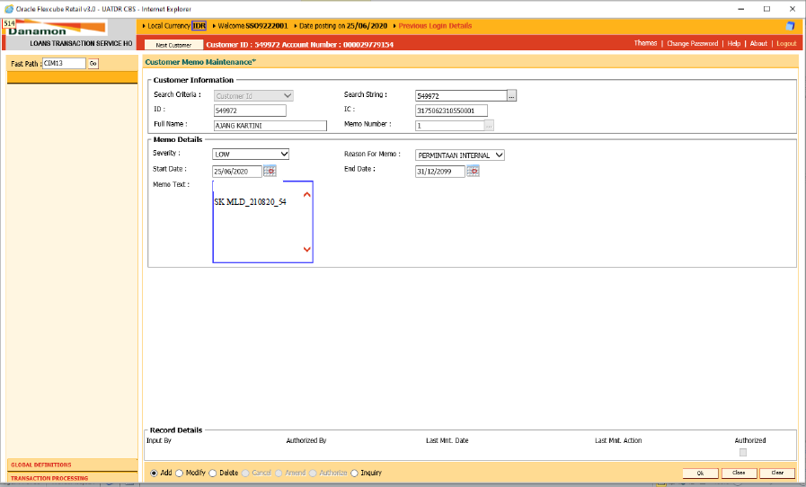

General sPECfications
Protocol: HTTPS
Method: POST
Authentication: Basic Authentication

DetaIL SpecIFciation

Header [Customer Memo MAINTENANCE]

- Header
- Header Specifications
content-type: application/json
Authorization: Basic Base64('username:password')
TxnKey: SHA-256 hashcode (channelID + svcCode + svcRqId + txnDate + userID + channelDirect + custId + memoSeverity + memoReason + memoStartDate + memoEndDate + memoText + memoNumber + flgOps)
Field Name | Mandatory | Data Type | Length | Format | Description | Remarks
channelId | M | STRING | 10 | Alphanumeric | Channel ID | Sample: MDLWR
svcCode | M | STRING | 15 | Alphanumeric | Service Request code | Sample: "NGI_CUSTMEMOMNT"
svcRqId | M | STRING | 40 | Alphanumeric | Service Request ID | Sample:  “991092019201sjajs”
txnDate | M | STRING | 14 | Numeric | Transaction Date of the request | Sample: 20230625162310
userId | M | STRING | 10 | Alphanumeric | User ID | Sample: APIINTOPR
channelDirect | M | STRING | 1 | Alphanumeric | To specify channel is sending the request to NCBS directly (Y) or via MW (N) | Sample: Y

- Header Sample [Customer Memo MAINTENANCE]
Authorization: "Basic xvFG8cvb3rTXM6MTIz"
TxnKey: "a2e7939e71cc46a5864aba85ad36bbff4030ea14e2f00fdbdd8d66f728cb0341"
"channelId": "MDLWR",
"svcCode": "NGI_CUSTMEMOMNT"
"svcRqId": "991092019201sjajs"
"txnDate: "20230625162310"
"userId": "APIINTOPR"
"channelDirect":"Y"

Body [Customer Memo MAINTENANCE]

Request [Customer Memo MAINTENANCE]
Field Name | Mandatory | Data Type | Length | Format | Description |  | Remarks
customerMemoDetails
custId | M | STRING | 10 | Numeric | Customer ID | Sample : 14409
memoSeverity | M | STRING | 1 | Alphanumeric | Memo Severity  L = LOW  H = HIGH | Sample: H
memoReason | M | STRING | 5 | Numeric | Reason For Memo  38 = PERMINTAAN NASABAH  39 = PERMINTAAN INTERNAL  40 = PERMINTAAN EKSTERNAL  41 = BLACKLIST BI  42 = REKENING PENIPUN  43 = FRAUD ATAU INDIKASI FRAUD  66 = U=UNDESIRABLE | Sample: 38
memoStartDate | O | STRING | 8 | Date | Memo Start Date(ddMMyyyy) | Sample: 01012024
memoEndDate | M | STRING | 8 | Date | Memo End Date(ddMMyyyy)  Note :- Mandatory for Add | Sample: 01012026
memoText | M | STRING | 240 | Alphanumeric | Memo Text  Note :- Mandatory for Add | Sample: High Risk for Blacklisting
memoNumber | M | STRING | 1 | Numeric | Memo Number  Note :- Mandatory for Update | Sample : 2
flgOps | M | STRING | 1 | Alphanumeric | Operation Code  a - Add  m- Update | Sample :- m

Request sample [Customer Memo MAINTENANCE]
Body
{
" customerMemoDetails ": {
“custId” : “14409”,
" memoSeverity ": "H",
" memoReason ": 38,
" memoStartDate ": "01012024",
" memoEndDate ": "01012026",
" memoText ": "High Risk for Blacklisting",
" flgOps" : "a"
}
}

Response [Customer Memo MAINTENANCE]
Response Header
- Header Specifications
content-type: application/json
Field Name | Data Type | Data Length | Format | Description | Remarks
Response
responseCode | STRING | 7 | Numeric | Response Code | Sample: 0000000
responseMessage | STRING | 40 | Alphanumeric | Response Message | Sample: SUCCESS
Response Body:

Response SAMPLE [Customer Memo MAINTENANCE]
Success case:
{
"response": [
{
"responseMessage": "Success",
"responseCode": "0000000",
}
],

"errors": [],
"traceId": "20230803165613126052380",
"timeStamp": "2023-08-03T16:56:20.191",
"channelId": "MDLWR",
"svcCode": “NGI_CUSTMEMOMNT",
"svcRqId": "991092019201sjajs ",
"success": true
}
Error case:
{
"response": [],
“errors”: [
"code": " ERR40002",
"message": "Customer Id Is Mandatory Input",
“type”: “Internal Server error”
],
"traceId": "20230620133714196046253",
"timeStamp": "2023-06-20T13:37:14.219",
"channelId": "MDLWR",
"svcCode": "NGI_CUSTMEMOMNT",
"svcRqId": "991092019201sjajs ",
"success": false
}

Response codes [Customer Memo MAINTENANCE]

Current list of NCBS status code will be used and extended list as below for NGI

Response Code | Response Message | Http Status | Description
000000 | Success | 200 | Transaction success
ERR40001 | Invalid Field Format {Field Name) | 400 | Invalid Format
ERR40002 | Invalid Mandatory Field {field name} | 400 | Missing or invalid format on mandatory field
ERR40101 | Invalid Token | 401 | Token found in request is invalid (Access Token Not Exist, Access Token Expiry)
ERR50001 | Internal Server Error | 500 | Something went wrong, please try again later

Additional Information

APPENDIX
RULE ID | IL RULE REQUEST and RESPONSE

END POINT URL

Transaction key generation and service processing URL:

https://cust-memo-mnt-ngisit.dbankke.uat.danamon.co.id/openapi/dev/fcr/ngi/v1/customer-memo/txn-key

https://cust-memo-mnt-ngisit.dbankke.uat.danamon.co.id/openapi/dev/fcr/ngi/v1/customer-memo

